# The user manual

This game was called “Towers” by author Katerina Potrus.

By your logic and mathematic skills, fast reaction and sense of humor you have to kill all evils and destroy their tower. But be careful and don’t let them destroy your army and tower.

## The main menu

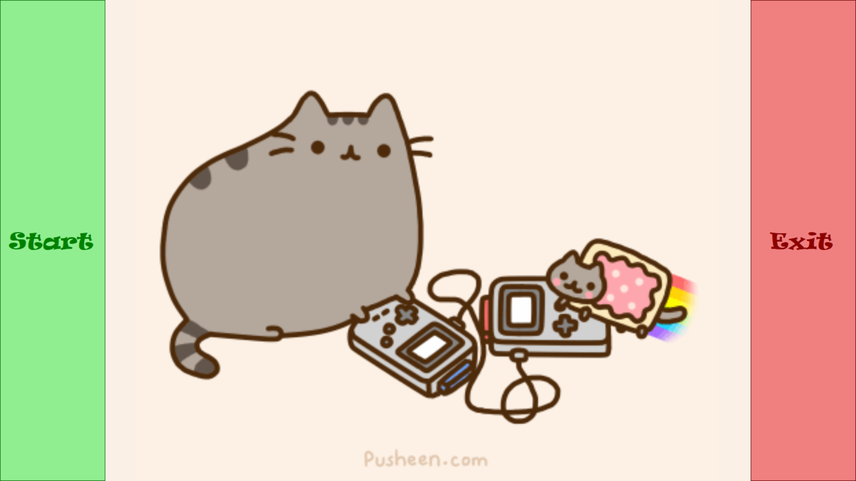

Figure 1The main menu

Press to Start the game Press to Exit

# The Shop

8

7

6

5

4

3

2

1

Figure 2The main shop

1 – Current Gold. Gold that you were given (=300). You can see sum, that was changed because of buying the chosen tower.

2 – The price of your tower.

3 – The picture of your tower.

4 – The button “Previous”. Helps to choose the tower of your dream.

5 - The button “Next”. Helps to choose the tower of your dream.

6 – The button “I`m ready”. Starts the game.

7 – Prices of knights.

8 – The image of knights. By clicking on it you can buy the knight.

## The Game

2

1

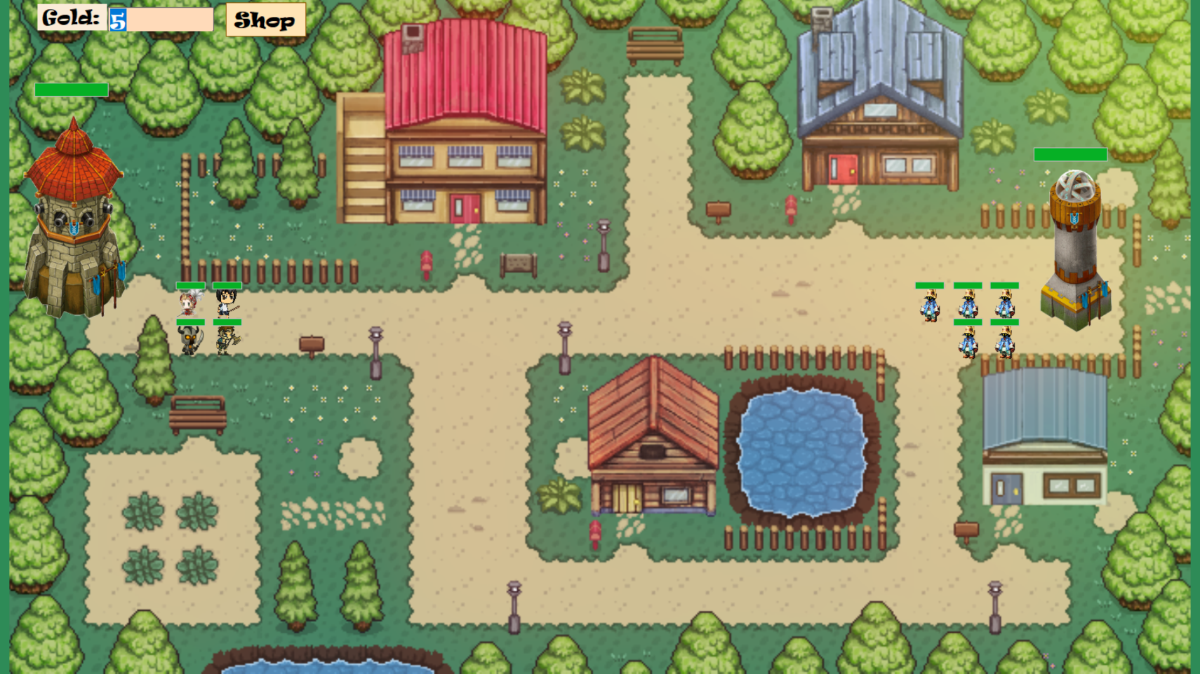

8

7

6

5

4

3

Figure 3The start of your fight

1 – The Button “Shop”. Helps to buy knights.

2 – Your current gold. If you want to earn, you have to kill evils. One evil cost 20 gold.

3 – Health points of your tower.

4 – Your picture of the tower.

5 – Your army. All knights have own health points. If you bought several of the one type of the knight – this type has several lives. To start fight – click on the one of knights.

6 – Enemy`s army. All evils have own health points.

7 – Evils` picture of tower.

8 – Health points of evils` tower.

## Shop in the fight field

1

3

2

Figure 4The shop during the fight

1 – The button “Close shop”. Click if you want to end your shopping.

2 – Current gold. If you haven`t enough gold, a buying will be unavailable.

3 – All pictures of knights in the game. By clicking on the picture, you can buy the new knight.

## Are you win or lose?

You will lose if your tower was broken:

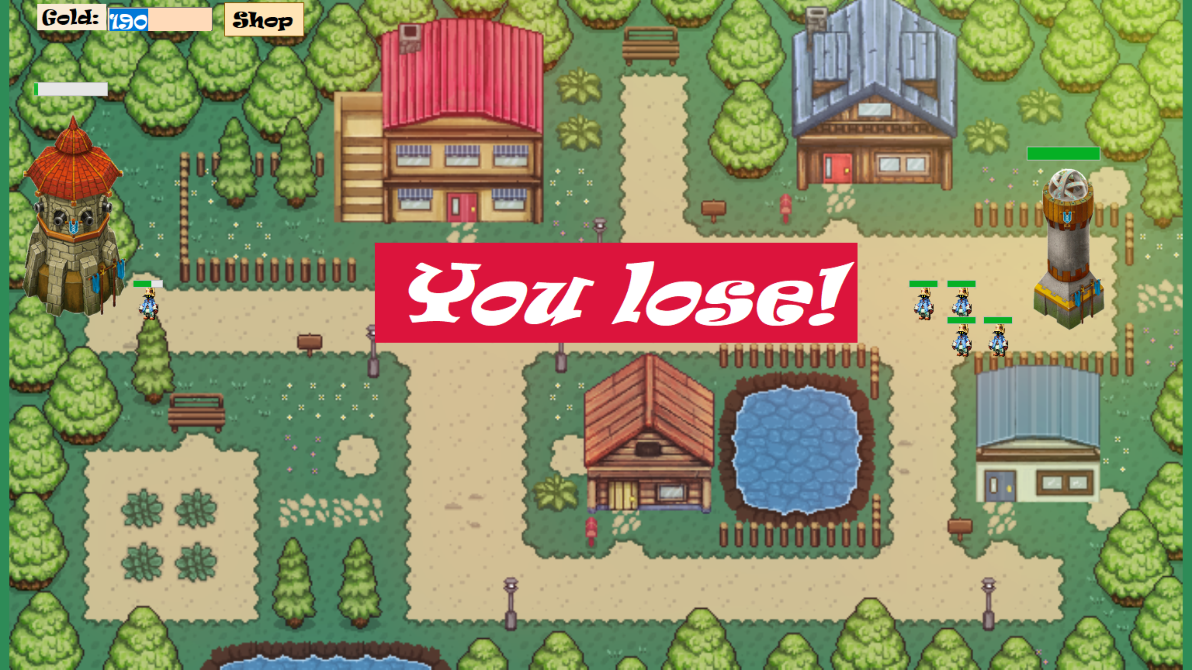

Figure 5You lose

You will win if enemy`s tower was broken:

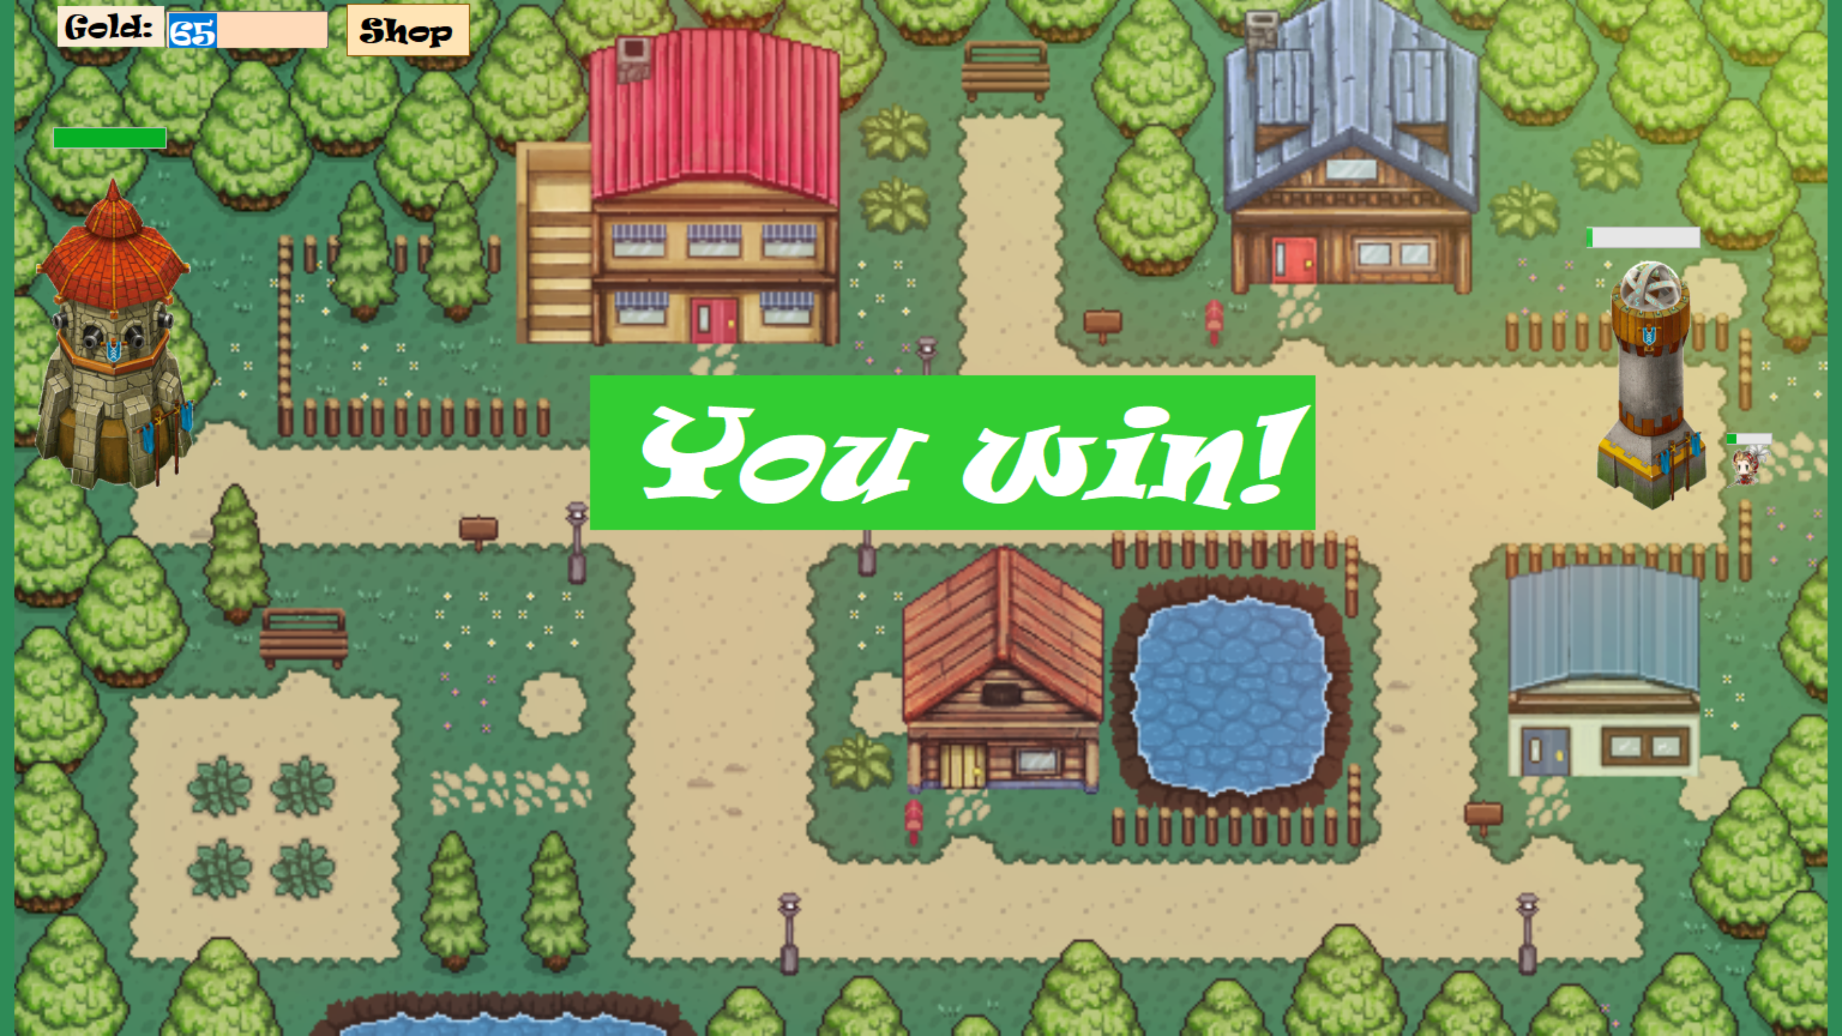

Figure 6You win

## The menu

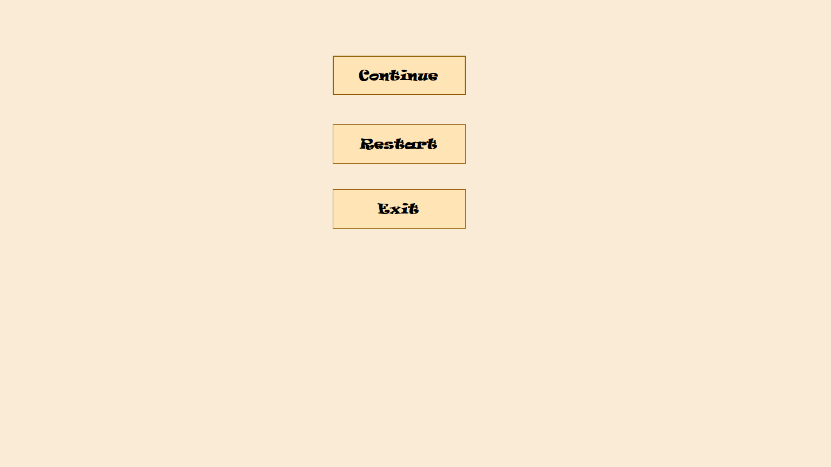

3

2

1

Figure 7The menu during the fight

1 – The button “Continue”. Press to continue your fight.

2 – The button “Restart”. Press to restart your fight.

3 – The button “Exit”. Press to close the application.